Periodic Table
Memorandum

Name: _______________________________

Your Cell Number:_______________________

Your Email: ________________________

Memorandum:

Question 1:

  - Alkali-metals.
  - Mendeleev.
  - Describe the following terms:
    - An atom or a molecule which an electron donates or lost
    - An atom which has lost an electron.
    - An atom which has gained an electron.
    - A molecule that consists of 2 identical atoms, built from the same element

Question 2:

  - D
  - D
Question 3:

- By using the Periodic table, supply the correct name for the below symbols:
  - Nitrogen
  - Carbon
  - Mercury
  - Sulphur
  - Phosphorous
  - Coper
  - Hydrogen
  - Silver
  - Zink
  - Uranium
  - Sodium
  - Chlorine
  - Calcium
  - Tin
  - Lead

Question 4:

Draw the atom diagrams to represent the following atoms:

  - Hydrogen

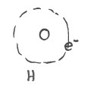

  - Argon
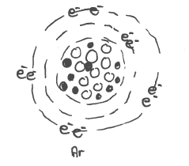

  - Lithium
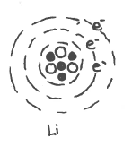

  - Sodium

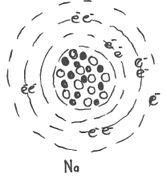

  - Carbon

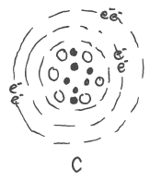

  - Chlorine

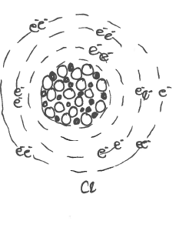
Question 5:

  - NH₃
  - H2O
  - CO₂
  - NaOH

Question 6:

  - Hg
  - Al
  - Au
  - Br
  - K
  - Mg
  - Be
  - Fe
  - Li
  - Sn

Question 7:

  - Valence- electrons: It is electrons that appear in the outer valence-orbital.
  - Weight Number: Is the total weight of the proton and the electrons in the core.
  - Atom Number: It is the amount of protons that occur in the core. (Of electrons in orbital)
  - Group: It is the vertical column on the Periodic table where elements with the same characteristics appear.
  - Period: It is the horizontal columns on the periodic table where the elements have similar characteristics.
  - Valence: It is the number of electrons in the outside energy level of an atom, which is available to bond with other atoms.
  - Alkali metals: The elements that occur in group 1 which has similar characteristics.
  - Halogens: The elements that occur in group VII.
  - Valence orbital: It is the outside orbital of an atom where unpaired electrons occur.
  - Noble Gasses: It is the elements in group VIII of which the valence orbital is full. These elements are unreactive. (Inert)

Question 8:

8.1 | The name of the element of which it is an atom | Chlorine
8.2 | The atom number | 17
8.3 | The Weight number | 35
8.4 | The amount of electrons | 17
8.5 | The amount of neutrons | 18
8.6 | The amount of nucleons | 17

Question 9:

Element | Symbol | Atom Number | Amount $p^{+}$ (protons) | Amount $e^{-}$  (electrons) | Weight Number | Amount $n^{°}$ (=massa-getal-$p^{+})$  (neutrons) | Amount of energy levels | Amount of valence- electrons
Helium | He | 2 | 2 | 2 | 4 | 2 | 1 | None
Carbon | C | 6 | 6 | 6 | 12 | 6 | 2 | 4
Nitrogen | N | 7 | 7 | 7 | 14 | 7 | 2 | 3
Magnesium | Mg | 12 | 12 | 12 | 24 | 12 | 3 | 2
Aluminum | Al | 13 | 13 | 13 | 27 | 14 | 3 | 3
Brimstone | S | 16 | 16 | 16 | 32 | 16 | 3 | 2
Phosphorous | P | 15 | 17 | 17 | 31 | 14 | 3 | 3

Question 10:

For this question you need colour pencils.

10.1 Draw the metal/non-metal step with a ruler on the periodic table. Also indicate where the metals and none metals occur.

1 2 3 4 5 6 7 8 9 10 11 12 13 14 15 16 17 18
Groups

H |  |  |  | Transitions Metals |  |  |  |  | Diatoms |  |  |  |  |  |  |  | He
Li | Be |  |  |  |  |  |  |  |  |  |  | B | C | N | O | F | Ne
Na | Mg |  |  |  |  |  | Fe |  |  | Cu | Zn | Al | Si | P | S | Cl | Ar
K | Ca |  |  |  |  |  |  |  |  | Ag |  |  | Ge | As |  | Br
 |  |  |  |  |  |  |  |  |  | Au |  |  |  | Sb | Te | I
 |  |  |  |  |  |  |  |  |  |  | Hg |  |  |  | Po | At

Noble Gasses
Half metals of metalloid
Alkali-earth metals
Alkali metals
Halogens

  - Hg
  - Halogens in Blue
  - Alkali-earth metals in Red
  - Alkali metals in period 4 Yellow.
  - Calcium.
  - P
  - 3
  - IV / 14
  - Halogens

Question 11:

  - Atom diagram of one oxygen atom

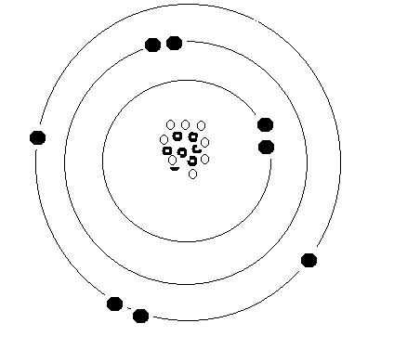
  - 1s² 2s² 2p⁴
  - Potassium Atom

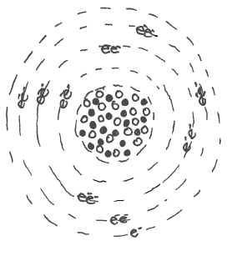

Question 12:

Complete the following table

Alkali metals | Lithium | Sodium | Calcium | Magnesium | Boron | Fluorine
Symbol | Li | Na | Ca | Mg | B | F
Atom number | 1 | 1 | 2 | 2
Period op periodic table | 2 | 3 | 4 | 3 | 2 | 2
Group number | 1 | 1 | 2 | 2 | 13 (III) | 17 (VII)
Amount valence- electrons | 1 | 1 | 2 | 2 | 3 | 7
Electron distribution | 1s²2s¹ | 1s²2s²2p⁶3s¹ | 1s²2s²2p⁶3s²3p⁶4s² | 1s²2s²2p⁶3s² | 1s²2s²2p¹ | 1s²2s²2p⁵
Phase | Solid | Solid | Solid | Solid | Solid
Colour | Silver white | Silver | Silver | Silver White | Black
Hardness | Soft | Soft | Soft | Bendable | Hard

