GRADE 7 MATHEMATICS EXEMPLAR EXAMINATION PAPER JUNE 2015 PAPER 2 TOTAL: 50 MARKS 1 HOUR

NAME AND SURNAME: ____________________ GR 7 ____
INSTRUCTIONS
1. Answer ALL questions.
2. Show your calculations for questions of two marks or more.
3. YOU MAY NOT USE A CALCULATOR for this paper.
Section A
Multiple Choice Questions
In this section, 4 possible answers are given for each question. Only ONE of the four options is correct. Circle the letter of the correct answer. If more than one letter is circled per question, no marks will be allocated for that question.
1. If the distance between two lines never changes, they are
A perpendicular B parallel C intersecting lines D rays

2. An angle that is bigger than 180°, but smaller than 360° is called a
A reflex angle B right angle C obtuse angle D acute angle

3. An isosceles triangle has
A three equal sides. B no equal sides.
C not one of the choices D two equal sides.

4. The perimeter of a square is 36 cm. The length of each side is
A 8 cm B 6 cm C 12 cm D 9 cm

5. 1 100 mm is equal to
A 11 m B 11 cm C 1,1 m D 11 000 cm
(5)

Section B Show all your calculations

Question 1

1.1 In the table below the illustrations of items are listed in column A and their names in column B. The illustrations do not correspond to the name next to it. Choose the correct name and write it opposite the illustration in column C. (5)

 | Column A – Illustration | Column B – Incorrect Name | Column C – Correct Name
1.1.1 |  | Line
1.1.2 | 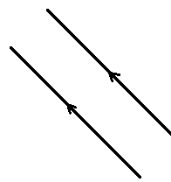 | Perpendicular line segments
1.1.3 |  | Line segment
1.1.4 | 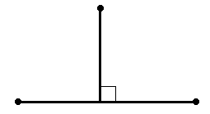 | Parallel lines
1.1.5 |  | Ray

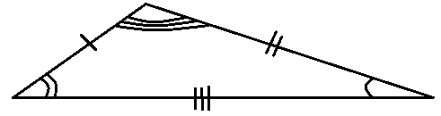
1.2. Classify the following triangles according to the length of their sides .
1.2.1 1.2.2
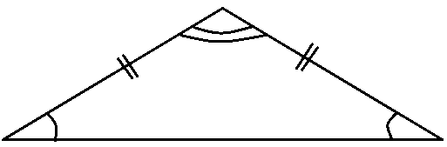

1.2.1 ___________________________ (1) 1.2.2 _______________________ (1)
[2]
1.3.1 What type of quadrilateral is EFGH? ______________________ (1)
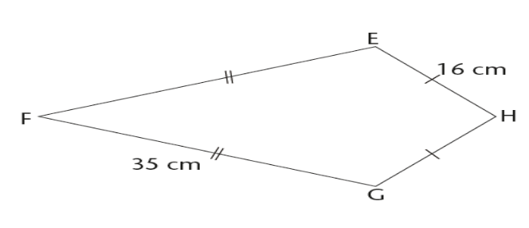
1.3.2 EH = 16 cm and FG = 35 cm. Complete:

EF = _____ mm ; GH = ______ mm. (2)
[3]

1.4 O is the centre of the circle below. Name the following line segments
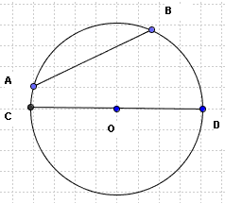

1.4.1) AB ___________________

1.4.2) CD ___________________

1.4.3) OD ___________________

[3]

1.5 If the diameter of a circle equals 15 cm, calculate the radius.
________________________________________________________________ [1]

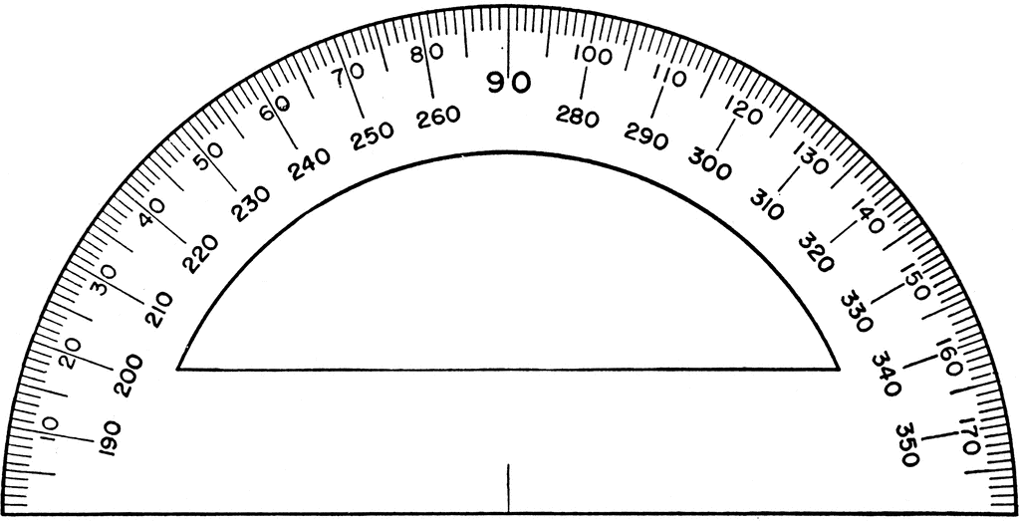
1.6 Write down the size of the angles indicated on the protractor.
E
A
B
C
D

1.6.1 angle AEC _______________ 1.6.2 angle BEA ______________ (2)
[2]

Question 2
The figure below shows various line segments joining and intersecting each other. The following angles are specially marked

$A\hat{F}C is \hat{1}$; $D\hat{B}G is \hat{2}$ en $A\hat{G}B is \hat{3}$.
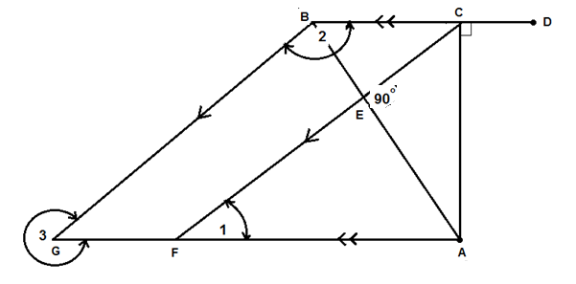

Write down
2.1. One pair of line segments which is parallel ____________ (1)
2.2. One pair of lines segments which is perpendicular _______________ (1)

2.3 Classify the angles (acute, right angled, obtuse, straight line, reflex, revolution).
2.3.1. $A\hat{F}C$ ($\hat{1}$) 2.3.2 $D\hat{B}G (\hat{2}$)
2.3.3. $A\hat{G}B$($\hat{3)}$ (3)
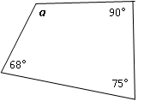
2.4 Calculate the size of angle a.
a
90°
68°
75°

________________________________________________ (3)
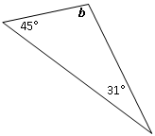
2.5 Calculate the size of angle b. (2)

____________________________________

[10]
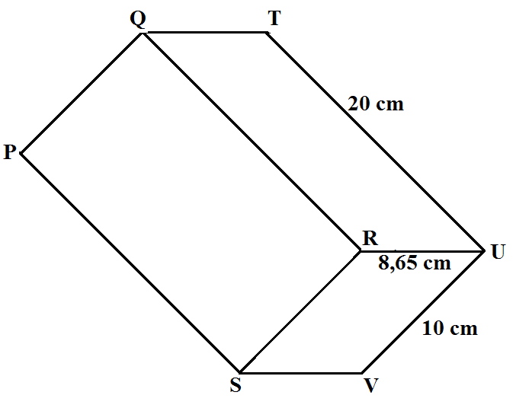
Question 3 The rectangular prism (cuboid) on the right has dimensions as indicated.

3.1. Indicate, for this prism, the number of:
3.1.1 faces _______
3.1.2 edges _______
3.1.3 vertices _______ (3)

3.2 Calculate
3.2.1. The perimeter of the face PQRS.
_______________________________________________________________________________________________________________________________________________________________________________________________________________ (2)

3.2.2 The total surface area of the rectangular prism (cuboid).
_____________________________________________________________________________________________________________________________________________________________________________________________________________________________________________________________________________________ (4)

3.2.3 The volume of the rectangular prism _________________________________________________________________________________________________________________________________________________________________________________________________________________________ (2)
[11]

Question 4
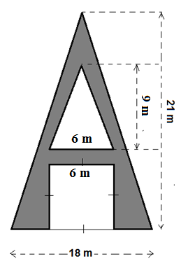
A marketing company ordered a giant letter A to fit onto the front of the tall building of their client, Alpha Enterprises. The bottom cut-out where vehicles van drive through, is a square with sides of 6 m. The top cut-out is a triangle with a base of 6 m and a height of 9 m. The letter is 21 m tall and 18 m wide at the bottom.

4.1. Calculate the area of the square that was cut out at the bottom. (2)
___________________________________
___________________________________
___________________________________

4.2. Calculate the area of the triangle that was cut out at the top. (2)
___________________________________
___________________________________
___________________________________

4.3. Calculate the area of the painted letter A. (4)
________________________________ __________________
__________________________________________________
__________________________________________________
[8]
Total: 50

