NAME: |  | TEACHER'S COMMENT
TEACHER:

CLASS:

MARK: BIOLOGY: /68
PHYSICAL SCIENCE: /90
TOTAL: /158
PERCENTAGE | BIOLOGY:  PHYSICS:  TOTAL:

HERZLIA MIDDLE SCHOOL

GRADE 8
NATURAL SCIENCE END OF YEAR EXAMINATION
24 NOVEMBER 2011
TIME: 90 Minutes
MARKS: 158

INSTRUCTIONS:
1 This paper consists of 26 pages, including one cover page and two
Answer Sheets. Check that you have them all.
2 Answer all questions on the paper in blue or black ink.
3 Read each question carefully before answering it. Pay attention to the mark allocation.
4 Plan your time carefully.
5 You may use a calculator.

BIOLOGY ANSWER SHEET

NAME :___________________________ CLASS: ______________

MULTIPLE CHOICES (USE PENCIL ONLY)

Choose the answer, which you consider most appropriate and cross the corresponding letter on this answer sheet.e.g. if your answer to 3 is d, indicate your choice like this:

1.3 | A | B | C | D

if more than one cross appears in any line, the answer will be marked wrong.

1.1 | A | B | C | D
1.2 | A | B | C | D
1.3 | A | B | C | D
1.4 | A | B | C | D
1.5 | A | B | C | D
1.6 | A | B | C | D
1.7 | A | B | C | D
1.8 | A | B | C | D
1.9 | A | B | C | D
1.10 | A | B | C | D

SECTION A: BIOLOGY (68 MARKS)
QUESTION 1 MULTIPLE CHOICE (10 MARKS)
Choose the correct answer and mark it with a cross on the Biology Answer Sheet provided.

1.1 The name of the scientist who concluded that cork was composed of tiny, hollow
boxes that he called cells:

A. Robert Brown
B. Robert Hooke
C. Antoni van Leeuwenhoek
D. Volta

1.2 What two parts do plant cells have that animal cells do not?

A. cell membrane, large vacuole
B. mitochondria, cell wall
C. chloroplast, large vacuole
D. cell wall, temporary vacuole

1.3 Which of the following is unicellular?
A. Amoeba
B. Sunbird
C. Arum Lily
D. Baobab

1.4 The living substance of cells is called:
A. cytoplasm
B. nucleoplasm
C. bioplasm
D. protoplasm

1.5 Which organelle is surrounded by a single membrane?
A. nucleus
B. vacuole
C. chloroplast
D. mitochondria

1.6 Which organelle is referred to as the “power house” of the cell?
A. chloroplast
B. nucleus
C. mitochondria
D. vacuole

1.7 The dark grains in the nucleoplasm are/is:
A. starch
B. oil
C. nuclear pores
D. chromatin

1.8 Which of the following is needed for photosynthesis?
A. chlorophyll
B. carbon dioxide
C. water
D. all of the above

1.9 Adina examined a cell under a microscope. She used a 10x eyepiece and a 10x
objective. What was the total magnification of the cell?

A. 10x
B. 100x
C. 20x
D. 1000x

1.10 The tough carbohydrate found in cell walls is called:

A. cellulose
B. cytoplasm
C. tonoplast
D. starch

QUESTION 2: MATCH THE COLUMNS (8MARKS)
Match the parts in COLUMN A with their functions in COLUMN B. Write the letter in the space provided next to the number.
COLUMN A COLUMN B
______2.1 chloroplast A. strength
______2.2 mitochondria B. excretion
______2.3 cell wall C. controls entry of molecules
______2.4 nucleus D. respiration
______2.5 cell membrane E. stores heredity characteristics
______2.6 animal vacuole F. photosynthesis
______2.7 plant vacuole G. metabolic reactions
______2.8 cytoplasm H. movement of water into the roots

QUESTION 3 GEOPHYTES (12 MARKS)
Read the following article taken off a gardening blog and answer the questions.
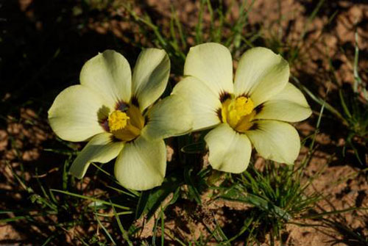
A new species from the iris family found near Worcester, is to be named Moraea vuvuzela by SANBI botanist Dr John Manning to commemorate South Africa’s hosting of the first Soccer World Cup on the African continent.
This pretty little bulb is currently known from just two localities between Rawsonville and Villiersdorp in the heart of the Cape Floral Region. Both known populations are threatened by agriculture and development, especially the enlargement of the Brandvlei Dam, and probably the species has disappeared already from parts of its range through the flooding of the Theewaterskloof Dam.
The name vuvuzela comes from the raucous air horn, approximately one metre in length, that commonly is blown by fans at soccer matches in South Africa. It commemorates the country’s hosting of the first Soccer World Cup on the African continent in June 2010. The colourful, flared flowers are appropriate associations with the name.
Moraea vuvuzela is severely threatened by agriculture and this blog is therefore linked to a conservation programme.
Says Dr Manning, a scientist taking part in this conservation programme, “The species was brought to our attention by a Rawsonville resident and conservationist Anso le Roux, who encountered scattered flowering plants of an unknown Moraea in unburned veld near Rawsonville in August 2006. But it was only after a controlled burn in February 2009 that the species appeared in flower in any number. In July of that year she alerted us to the appearance of hundreds of flowering individuals and we were then able to gather material for description and illustration. Shortly thereafter, conservationist Rupert Koopman and members of the Custodians of Rare and Endangered Wildflowers (CREW) located a second flowering population of the species near Villiersdorp. “Subsequently, we have associated the species with at least two earlier, unnamed collections from Franschoek Forest Reserve gathered in 1937 and 1940.”
Source: SANBI

3.1 Define the term geophyte. (2)
_________________________________________________________________________________
_________________________________________________________________________________
3.2 Explain why this flower was given the species name vuvuzela. (2)
_________________________________________________________________________________
_________________________________________________________________________________
3.3 What is the conservation status of the Moraea vuvuzela? (2)
_________________________________________________________________________________
_________________________________________________________________________________
3.4 Why did this species appear after a fire? (1)
___________________________________________________________________
3.5 How have people caused the population of Moraea vuvuzela to drop? (1)
___________________________________________________________________
3.6 The Grade 8s regularly visited the fynbos garden to observe the geophytes.
3.6.1 Give three things that you recorded on these visits. (3)
_________________________________________________________________________________
_________________________________________________________________________________
_________________________________________________________________________________
_________________________________________________________________________________
3.6.2 Think of an idea for a Science Expo project related to geophytes. (1)
_________________________________________________________________________________
_________________________________________________________________________________

QUESTION 4 (14 MARKS)
1_______________________________
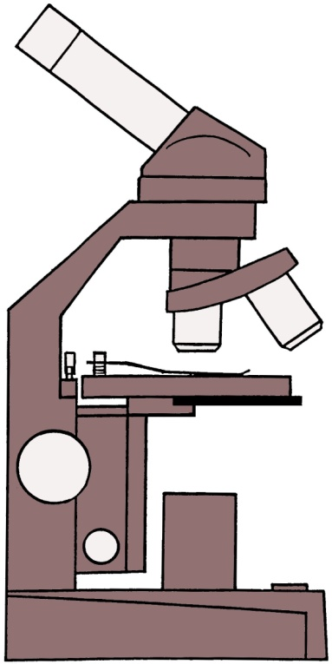
5_____________________________
4______________________________
2______________________________
3______________________________
6____________________________

HEADING___________________________________________________________

4.1 Give the diagram a heading. (1)

4.2 Give the labels in the spaces provided. (6)

4.3 Explain the function of the following numbered parts. (4)

Part | Function
1
2
4
5

4.4 Explain how to look after a microscope. Give three points. (3)
_________________________________________________________________________________
_________________________________________________________________________________
_________________________________________________________________________________
_________________________________________________________________________________
_________________________________________________________________________________
_________________________________________________________________________________

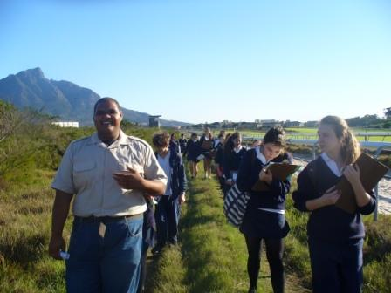
QUESTION 5 KRCA(5 MARKS)

5.1 What does KRCA stand for? (1)
________________________________________________________________________________
5.2 The Sandplein fynbos in this region is critically endangered. What factors have
caused the loss of these species? Give four factors. (4)

_________________________________________________________________________________
_________________________________________________________________________________
_________________________________________________________________________________
_________________________________________________________________________________
_________________________________________________________________________________
_________________________________________________________________________________
QUESTION 6: CELLS (8 MARKS)
You have been asked to make a model of a generalised animal cell out of everyday edible materials. Use the following items shown below to make the cell.
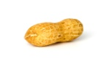
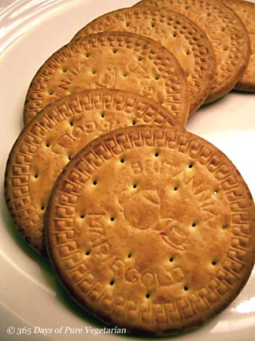


monkey nuts Marie biscuits jelly cling wrap
State what cell part the item represents and why you have chosen the substance.

ITEM | CELL PART | REASON
Monkeynuts

Marie Biscuits

Jelly

Cling Wrap

QUESTION 7: CELLS (11 MARKS)
7.1 Give the labels for the following diagram. (6)
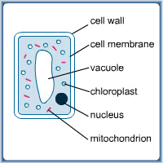
6
5
4
3
2
1

7.2 Draw ONE of the following organelles in detail:
nucleus or mitochondrion or chloroplast (5)
Give your diagram four labels and a heading.

7.3 Complete the following table. (2)
Cell type | Cell length or diameter (in millimetres) | Cell length or diameter (in micrometres)
Human liver |  | 20
Yeast |  | 8

7.4 Define the following terms:
7.4.1 cytology (1)
_________________________________________________________________________________
_________________________________________________________________________________
7.4.2 organelle (2)
_________________________________________________________________________________
_________________________________________________________________________________
_________________________________________________________________________________
_________________________________________________________________________________

PHYSICS AND CHEMISTRY ANSWER SHEET

NAME: ___________________________ CLASS: ______________

MULTIPLE CHOICES (USE PENCIL ONLY)

Choose the answer, which you consider most appropriate and cross the corresponding letter on this answer sheet.e.g. if your answer to 3 is d, indicate your choice like this:

1.3 | A | B | C | D

if more than one cross appears in any line, the answer will be marked wrong.

1.1 | A | B | C | D
1.2 | A | B | C | D
1.3 | A | B | C | D
1.4 | A | B | C | D
1.5 | A | B | C | D
1.6 | A | B | C | D

SECTION B PHYSICS & CHEMISTRY 89

MULTIPLE CHOICES (6MARKS)

Choose the correct answer and mark it with a cross on the Physics & Chemistry Answer Sheet provided.

1.1 The particle model helps us to understand the state of a substance. A liquid substance can be represented by model …

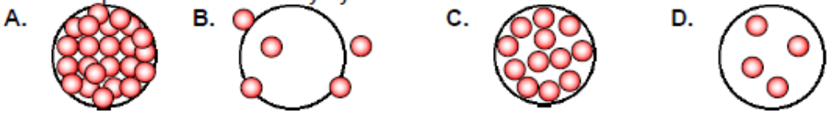

1.2
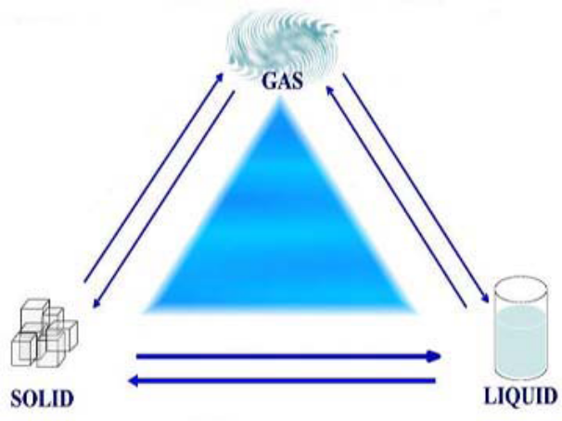
When a substance undergoes a change of state it can use energy or give off energy. The change that occurs when a substance changes from a liquid to a gas is referred to as …

A. deposition
B. sublimation
C. evaporation
D. condensation

1.3 It is often difficult to decide if a change is physical or chemical, so certain clues will help you decide if a chemical change has occurred. The only main evidenc that will guarantee a chemical change has occurred is …

- colour change
- heat is released or absorbed
- the phase changes
- evaporation occurs
1.4 Different resistors are used for different application. The major application for resistors is to …

- Produce heat only
- Produce light only
- Produce both heat and light
- Produce electricity

1.5 The only compound that contains three different elements is:

A. H₂O Water
B. C₆H₁₂O₆ Glucose
C. CO₂ Carbon dioxide
D. NO₂ Nitrogen dioxide

1.6 Choose the incorrect statement about elements

- Elements can be easily split into simpler atoms
- Elements are basic building blocks of matter
- Elements joined together form compounds
- Elements are represented by letters on the Periodic Table

QUESTION 2 DEFINITIONS (10MARKS)
Briefly define the following terms - 1 mark each.
2.1 Atom
___________________________________________________________________
___________________________________________________________________
2.2 Molecule
___________________________________________________________________
___________________________________________________________________
2.3 Compound
___________________________________________________________________
___________________________________________________________________
2.4 Current
___________________________________________________________________
___________________________________________________________________
2.5 Voltage
___________________________________________________________________
___________________________________________________________________
2.6 Anode
___________________________________________________________________
___________________________________________________________________
2.7 Battery
___________________________________________________________________
___________________________________________________________________
2.8 Malleable
___________________________________________________________________
___________________________________________________________________

2.9 Electrolyte
___________________________________________________________________
___________________________________________________________________
2.10 Conductor
___________________________________________________________________
___________________________________________________________________
QUESTION 3(12MARKS)

An experiment was done to see how compounds are formed. Iron was mixed with sulphur and then the mixture was later on heated in a test tube.

Draw the diagrams of the experiment in the space below. (5)
NB:Only for the new compound being formed.

3.1 A magnet covered in a transparent plastic bag was brought closer to the mixture before heating.

Write down the observation for this experiment. (2)

___________________________________________________________________

___________________________________________________________________

    - After heating the mixture over a Bunsen burner the contents started glowing then the contents were allowed to cool.

Write down the chemical word equation that represents the reaction in the test tube. (3)

___________________________________________________________________

    - What two conclusions can you reach from this experiment in 3.2.1? (2)

Conclusion 1

_____________________________________________________________________

______________________________________________________________________

Conclusion 2

_____________________________________________________________________

________________________________________________________________________

QUESTION 4 (10MARKS)

An alloy is a mixture of elements. The table shows the mass of each element present in 100 g of five different alloys, bronze, solder, steel, stainless steel and brass.

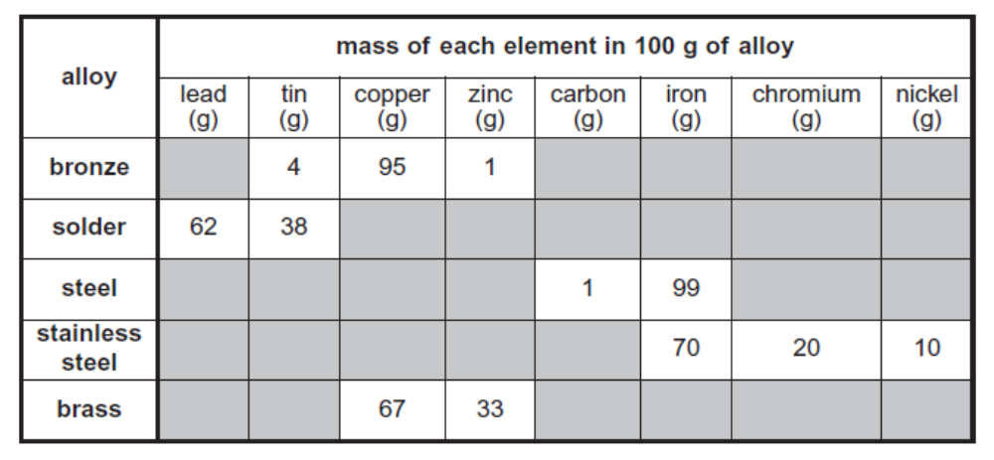

4.1 Which alloy in the table above contains an element which is a non-metal? (1)

___________________________________________________________________

4.2 Which two alloys in the table contain only two metals? (2)

__________________________ and _____________________________________

4.3 Another alloy called nichrome contains only the elements chromium and nickel. 100 g of nichrome contains 20 g of chromium. How much nickel does it contain? (2)

__________________________________________________________________

4.4 Joe bought a potted plant. He kept it well watered but some of the leaves
turned yellow. He then thought that the plant did not have enough minerals.
The table below gives information about minerals.

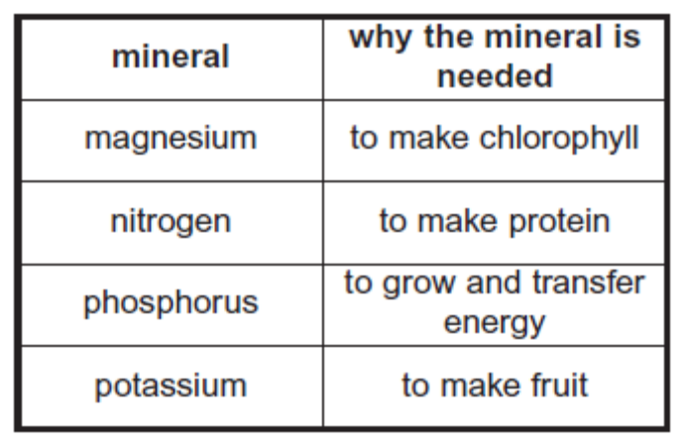

Joe bought some fertilizer for his plant.
The names and formulae of four different fertilizers are shown below.

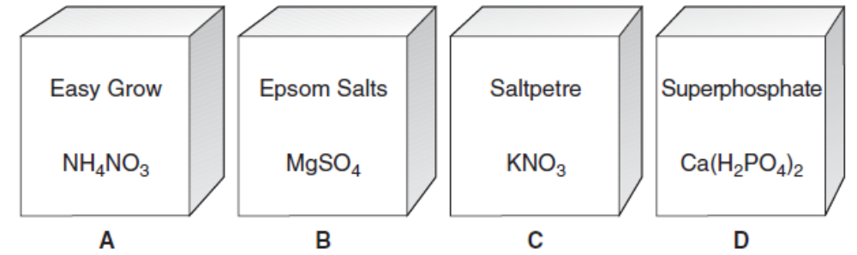

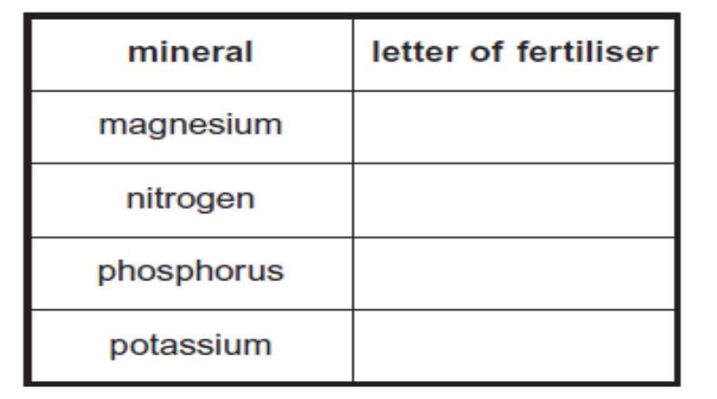

4.6 Write down the letter in the above table that corresponds to the fertilizer it is found in. (see pg 19) (4)

4.7 Easy Grow is ammonium nitrate, NH₄NO_{3.}
How many different elements are present in ammonium nitrate? (1)

___________________________________________________________________

4.8 Which elements are METALS and NON METALS present in the formula of Epsom salts? Write their symbols only. (4)

Metal/s _______________________________

Non-Metal/s____________________________

4.9 Write down 2 characteristics of metals.

___________________________________________________________________

___________________________________________________________________

QUESTION 5 (26MARKS)
  - Draw a circuit diagram with one light bulb, 2 cells and 1 closed switch. (4)

5.2 Give two disadvantages for light bulbs connected in series. (2)
________________________________________________________________
________________________________________________________________
5.3 Give two advantages for light bulbs connected in parallel. (2)
________________________________________________________________
________________________________________________________________

  - The diagram below shows a simple electrical circuit.

Complete the table below correctly matching each of the names of the components in the circuit with one of the labels A, B, C or D. (8)
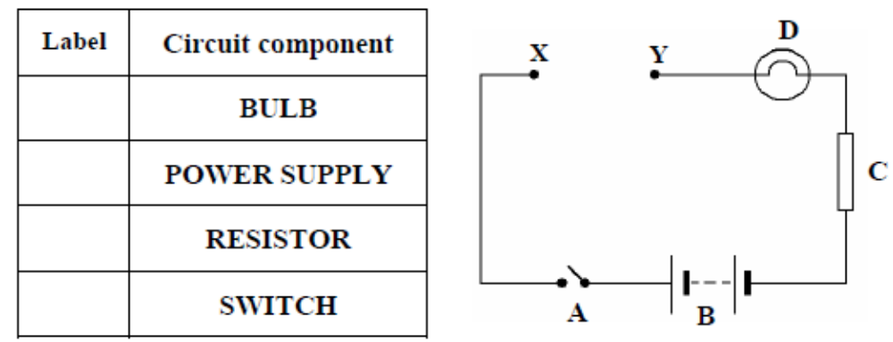
5.5 You are given a piece of copper metal and a piece of timber. Which piece, metal or wood, should you connect between X and Y in order that the bulb would light when the switch is closed? (3)
________________________

Give a reason for your choice.

Reason __________________________________________________________

__________________________________________________________________

5.6 The diagram shows a three-pin plug with the back removed. (3)
Answer the questions below using the table.

    - In the table below write the letter X opposite the name of the green and yellow wire.

    - Write the letter Y opposite the name of the blue wire.

    - Write the letter Z opposite the name of the brown wire.

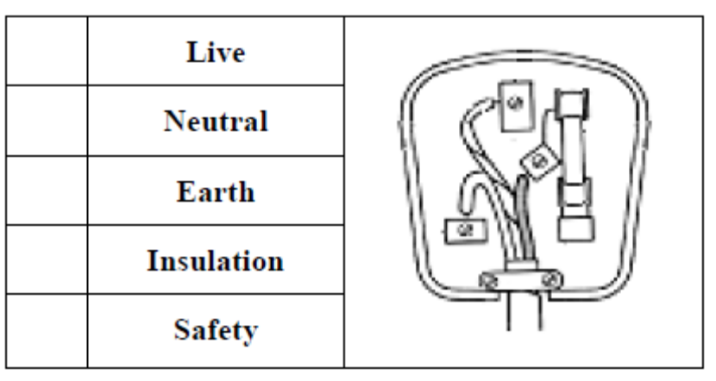
5.6.4 Explain how a fuse works in an electric circuit? (2)

___________________________________________________________

___________________________________________________________
  - The diagram below shows a common light bulb. Complete the table by writing the letter B beside the two main energy changes that take place when the bulb is in use. (2)

.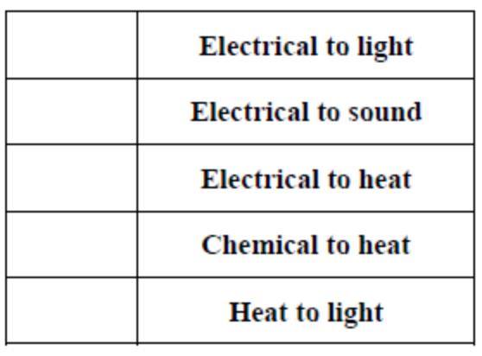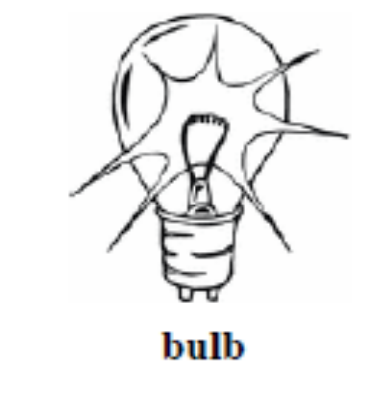

QUESTION 6 (9MARKS)
Mr Joseph prepared the following experiment to breakdown a green compound called copper chloride by passing current through it. Study the diagram below and answer the questions that follow.
+

  - Identify the anode by writing letter X and cathode letter Y on the electrode.(2)
  - During the experiment one of electrodes had bubbles accumulate. (2)
6.2.1 Name the electrode at which the bubbles are produced?
______________________________________________________________
6.2.2 What is the gas produced at this electrode. ___________________________________________________________________
  - During the experiment one of electrodes turned orange/brown.
    - Name the electrode at which the brown substance accumulated (2)
______________________________________________________________
    - What is the element that was produced at this electrode?
___________________________________________________________________

  - What aim would you give to this experiment? (1)
____________________________________________________________________________________________________________________________
  - Suggest a hypothesis for this experiment. (2) ____________________________________________________________________________________________________________________________
QUESTION 7 SWITCHES (16MARKS)
A switch is a convenient way of breaking a circuit. The following circuits were constructed by grade 8C. Study these circuits and answer the questions that follow.
CIRCUIT 1
A
B
  - Complete the following table by writing all the combinations. In the switch columns write open or closed and in Bulb column write on or off. (4)
SWITCH A | SWITCH B | BULB
 |  | On
Closed |  | off
 | closed | off
  - Why is this type of switch considered a safety switch? (2)
______________________________________________________________________________________________________________________
7.3 The lamp on the circuit below can be switched on and off from two different places.
CIRCUIT 2
A
B
7.3.1Complete the table by inserting on, off for the bulb or open, closed for the switch. (8)
SWITCH A | SWITCH B | BULB
 |  | On
open
Closed
 |  | Off

