Overberg Education District

GRADE 8

EXEMPLAR PAPER 2

MATHEMATICS

November 2014

MARKS: 60
TIME: 1h15min

This paper consists of 7 pages and 1 Annexure

INSTRUCTIONS AND INFORMATION

1. | This paper consists of THREE questions. Answer ALL THREE questions.
2. | Answer QUESTION 1.2.1 on ANNEXURE A. Write your name in the space the ANNEXURE and submit with your ANSWER BOOK.

3. | Number the answers correctly according to the numbering sytem used in this question paper.

4. | Start EACH question on a NEW page.

5. | You may use an approved calculator (non-programmable and non-graphical), unless stated otherwise.

6. | Show ALL the calculations clearly.

7. | Round off ALL the final answers off to TWO decimal places, unless stated otherwise.

8. | Indicate units of measurement, where applicable.

9. | Write neatly and legibly.

QUESTION 1
1.1 | The histogram below shows the number of athletes in specific age groups who participated in the Two Oceans Half Marathon in March 2013.  The oldest runner was 79 years.  number of athletes  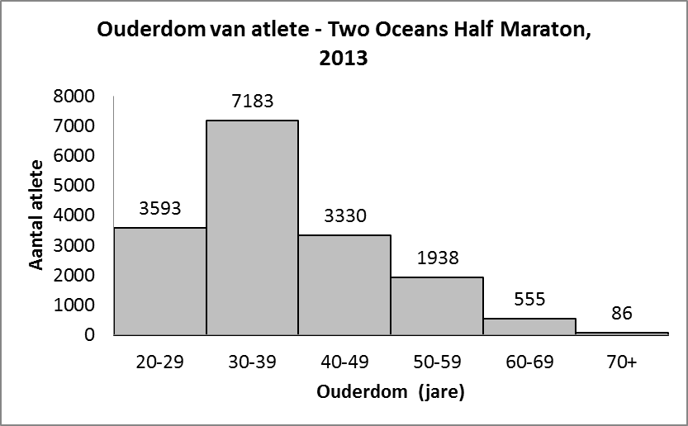  Age group (years)  Age of athletes – Two Oceans Half Marathon, 2013
 | (a) | How many athletes under 30 years participated in the Two Oceans Half marathon? | (2)
 | (b) | In what age group did the most athletes participate in the Two Oceans Half Marathon? | (1)
 | (c) | How many athletes in total participated in the Two Oceans Half marathon? | (3)
 | (d) | Compare the number of athletes younger than 50 to those 50 and older. Describe your observations and give a possible reason for your observations. | (3)
1.2 | The following table shows the monthly rainfall figures for two towns over a period of one year.
  Monthly rainfall figures (in mm)
   | J | F | M | A | M | J | J | A | S | O | N | D
  Town A | 4 | 7 | 6 | 13 | 19 | 23 | 25 | 17 | 8 | 6 | 5 | 7
  Town B | 14 | 17 | 15 | 5 | 7 | 4 | 3 | 9 | 10 | 11 | 13 | 19
 | 1.2.1 | Draw a line graph of Town B on Addendum A. | (6)
 | 1.2.2 | In what season does Town A get the most rain? | (2)
 |  |  | [17]
QUESTION 2

2.1. | Determine the length of b.
 | 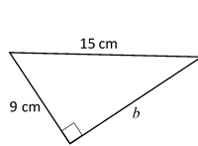 |  | (3)
2.2 | Jaco wants to build a cement path of one meter (1m) width around a rectangular swimming pool with dimensions, 7m × 5m. See sketch below.  A B  1m  1m  5m  D C  7m
 | Do the following calculations to help Jaco to determine the total area of the cement path:
 | 2.2.1 | Determine the length and width of rectangle ABCD, and then its area. | (3)
 | 2.2.2 | Calculate the area of ​​the pool. | (2)
 | 2.2.3 | Calculate the area of ​​the concrete path. | (2)
2.3 | A cylindrical can Tasty Tuna has a height of 45 mm and a diameter of 88 mm.
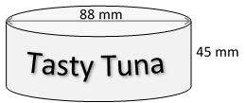

Neem $π$ =3,142

 | 2.3.1 | Calculate the volume of the can correct to the nearest two decimal places. | (3)
 | 2.3.2 | Calculate the surface area of ​​the can. | (3)
 |  |  | [16]

VRAAG 3
3.1 | Link the statement in the right column to the correct one in the left column:  Write the number with the correct letter next to it, eg. 1a |  | (5)
  Quadrilateral | Statement
  1) Kite | a) All sides are equal, but angles are not equal.
  2) Rhombus | b) A rectangle whose sides are equal.
  3) Rectangle | c) Two pairs of adjacent sides are equal.
  4) Square | d) Only one pair of opposite sides are parallel.
  5) Trapezium | e) The opposite sides are equal and all angles are right angles.
3.2 | In this sketch, AB // EC and AD // BC, AB G = 63 ° and AG B = 56 °.
 | 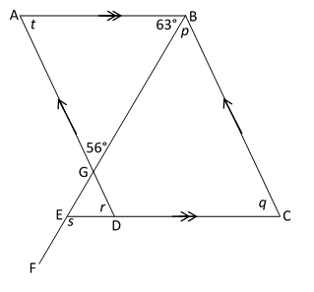
 | Calculate the size of p, q, r, s and t |  | (10)
3.3 | Calculate the size of the angles a and b in the figure below.
 | b  62°  70°  a  26°  85°  100° |  | (4)
3.4 | Solve for x in the triangle below:
 | 4x  x  2x+40º |  | (4)
3.5 | Triangles ABC and DEF are congruent. Determine the value of F.  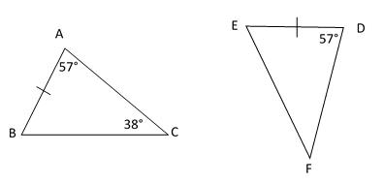 |  | (1)
3.6 | In the figure below, ABCD is a parallelogram.
25cm
A B
140°

17cm

D C

 | 3.6.1 | Write down the length of BC. | (1)
 | 3.6.2 | Find ∠ B | (2)
 |  |  | [27]
 | TOTAL: 60

ANNEXURE A:

NAME OF LEARNER: _______________________________

GRADE 8 ( )

