Exercise 2015-8ER-00003(1)

(1) Use quad paper or graph paper and draw the following on the same Cartesian plane:

(a) M and N, for M das the reflection of N(-1 ; 5) in the y-axis.
(b) ST and S'T' with S(1 ; 2) and T(2 ; 5) if ST $→$ S'T' is a rotation of 180$°$.
(c) $∆$ ABC translates 4 units upwards and 5 units to the left.
Draw both $∆$ ABC and ∆ A' B' C'. A(4 ; 1), B(4 ; -5) and C(2 ; -5)

(2) Draw at least THREE lines of symmetry in on each figure, if possible:

(a) (b) (c)

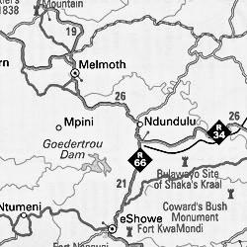
(3) If the scale on the map is
1:700 000, calculate the true direct
distance (as the crow flies),
between Melmoth and eShowe.

(4) (a) Is ∆ ABC a reflection of ∆ CDE
in the line MN?

(b) Is ∆ ABC a translation of ∆ PQR?
If so, describe the translation.

(c) Is ∆ ABC an enlargement / reduction
of ∆ STV? If so, write the factor of
enlargement / reduction.

(5) (a) Write the coordinates of
J, K, L, M and N.

(b) Draw J'K'L'M'N' if
JKLMN $→$ J'K'L'M'N' as a
translation of: (x + 2 ; y + 12)

(c) Write the coordinates of
J ', K ', L ', M ' and N '.

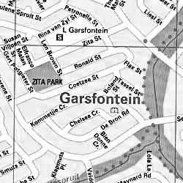
(6) Scale 1:15 000

If necessary, round off correct to 4 dec.

(a) Calculate the distance (in km) of
Zita street, between Gert
Potgieter street and Petronella
street.

(b) Calculate the area
of Zita Park in km$²$.

(c) Determine what the scale will be if the
actual distance of Zita street between Len
Brown street and Petronella street, is 770 m.

